1.1 Write a Python Program(with class concepts) to find the area of the triangle using the below

formula.

area = (s*(s-a)*(s-b)*(s-c)) ** 0.5

Function to take the length of the sides of triangle from user should be defined in the parent

class and function to calculate the area should be defined in subclass.

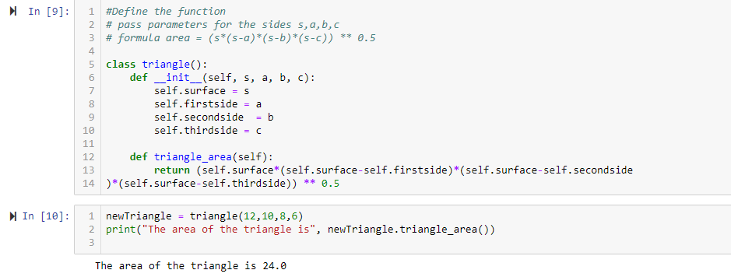

**Code:**

#Define the function

# pass parameters for the sides s,a,b,c

# formula area = (s*(s-a)*(s-b)*(s-c)) ** 0.5

class triangle():

def __init__(self, s, a, b, c):

self.surface = s

self.firstside = a

self.secondside = b

self.thirdside = c

def triangle_area(self):

return (self.surface*(self.surface-self.firstside)*(self.surface-self.secondside

)*(self.surface-self.thirdside)) ** 0.5

newTriangle = triangle(12,10,8,6)

print("The area of the triangle is", newTriangle.triangle_area())

1.2 Write a function filter_long_words() that takes a list of words and an integer n and returns

the list of words that are longer than n.

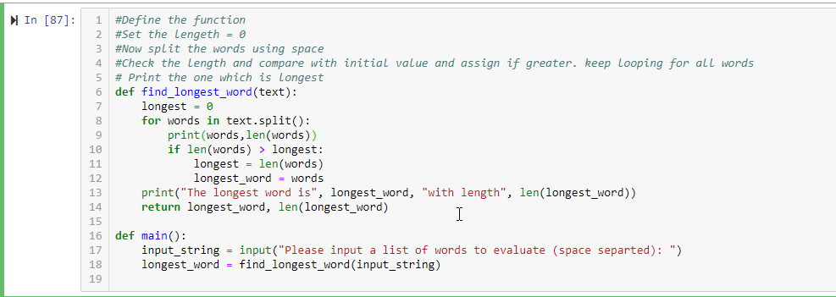

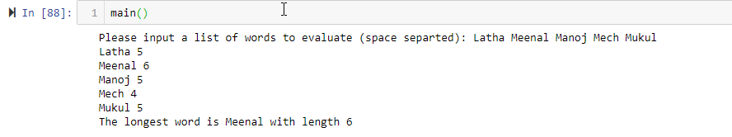

**Code:**

#Define the function

#Set the lengeth = 0

#Now split the words using space

#Check the length and compare with initial value and assign if greater. keep looping for all words

# Print the one which is longest

def find_longest_word(text):

longest = 0

for words in text.split():

print(words,len(words))

if len(words) > longest:

longest = len(words)

longest_word = words

print("The longest word is", longest_word, "with length", len(longest_word))

return longest_word, len(longest_word)

def main():

input_string = input("Please input a list of words to evaluate (space separted): ")

longest_word = find_longest_word(input_string)

2.1 Write a Python program using function concept that maps list of words into a list of integers

representing the lengths of the corresponding words.

Hint: ​If a list [ ab,cde,erty] is passed on to the python function output should come as [2,3,4]

Here 2,3 and 4 are the lengths of the words in the list.

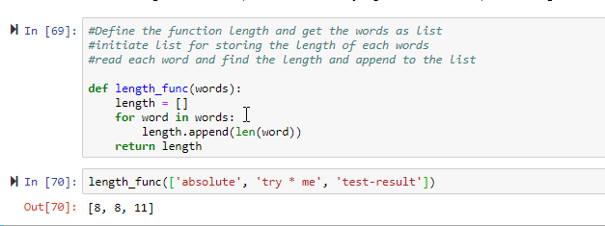

**Code:**

#Define the function length and get the words as list

#initiate list for storing the length of each words

#read each word and find the length and append to the list

def length_func(words):

length = []

for word in words:

length.append(len(word))

return length

2.2 Write a Python function which takes a character (i.e. a string of length 1) and returns True if

it is a vowel, False otherwise.

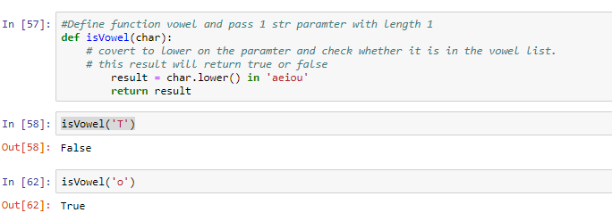

**Code:**

#Define function vowel and pass 1 str paramter with length 1

def isVowel(char):

# covert to lower on the paramter and check whether it is in the vowel list.

# this result will return true or false

result = char.lower() in 'aeiou'

return result